Anand Puranik

Emp id - 2020001156

Step Function Exercise: Ec2 Lambda state change

1. Create lambda function with the appropriate role for start, stop and terminate an EC2 Instance.
2. Goto aws step function → create state machine
3. Create state ‘start’, or ‘stop’ or ‘terminate’ or ‘exit’

Json code-

{

"Comment": "State machine for ec2",

"StartAt": "instancestate",

"States": {

"instancestate": {

"Type" : "Choice",

"Choices": [

{

"Variable": "$.instancestateType",

"StringEquals": "START",

"Next": "start_state"

},

{

"Variable": "$.instancestateType",

"StringEquals": "STOP",

"Next": "stop_state"

},

{

"Variable": "$.instancestateType",

"StringEquals": "TERMINATE",

"Next": "terminate_state"

}

],

"Default": "exit_state"

},

"start_state": {

"Type": "Task",

"Resource": "arn:aws:lambda:us-east-2:783323902162:function:StartEc2Instance",

"End": true

},

"stop_state": {

"Type": "Task",

"Resource": "arn:aws:lambda:us-east-2:783323902162:function:StopEc2Instance",

"End": true

},

"terminate_state": {

"Type": "Task",

"Resource": "arn:aws:lambda:us-east-2:783323902162:function:TerminateEc2Instance",

"End": true

},

"exit_state": {

"Type": "Fail",

"Cause": "Not instance state"

}

}

}

1. Create new role to step function
2. Provide json input for for ‘start’, or ‘stop’ or ‘terminate’ or ‘exit’ states.

Input-

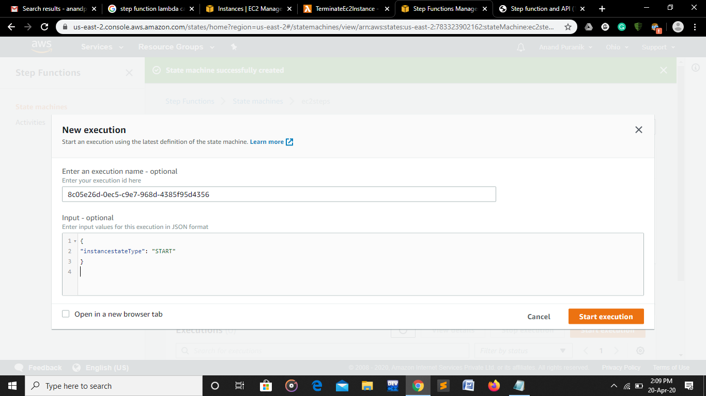

output-

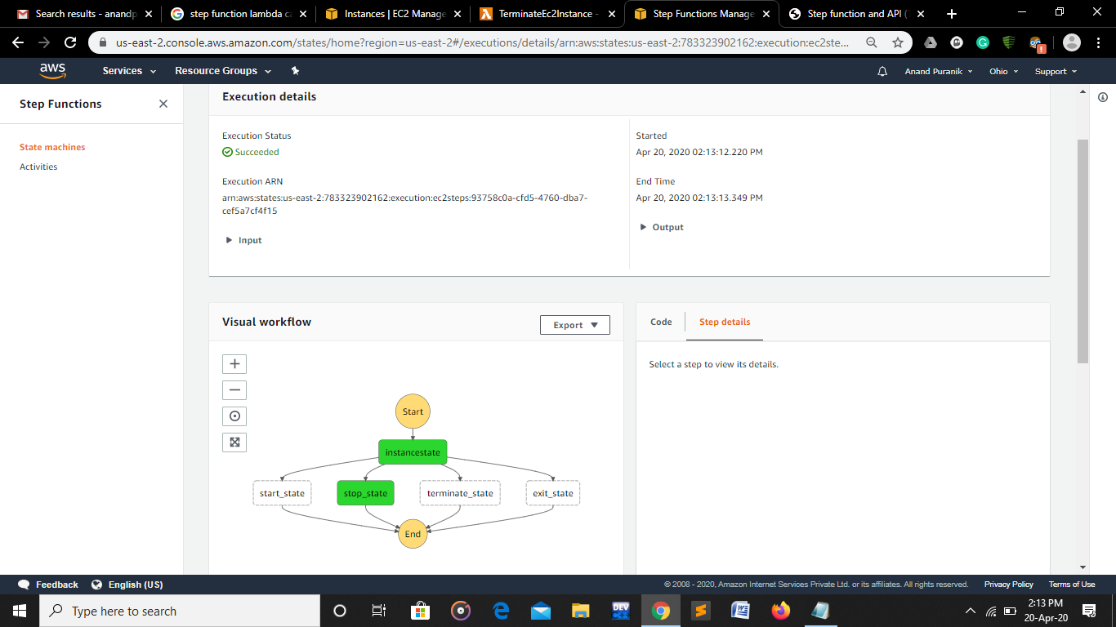

Ec2Instance Stopped

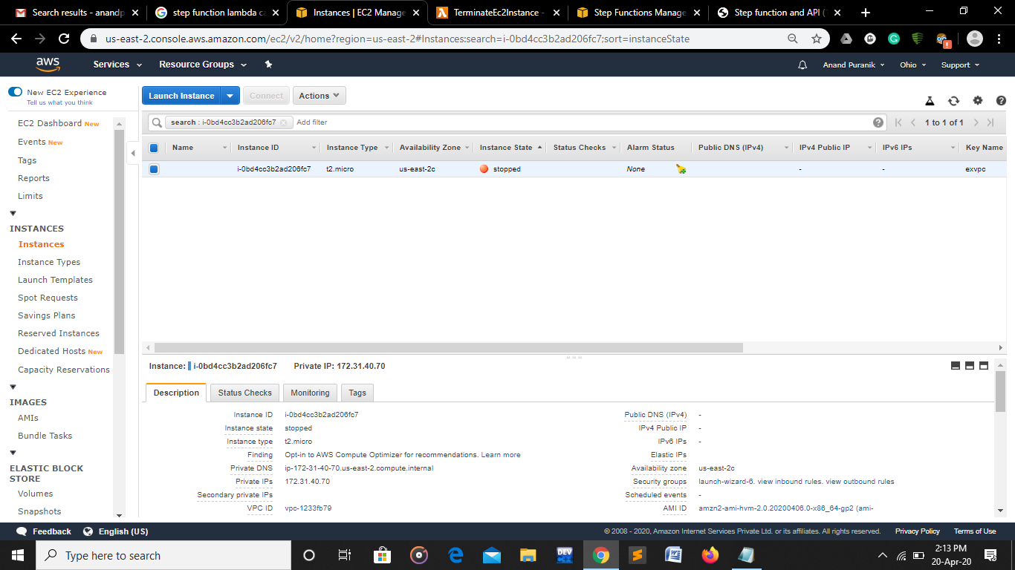

4.

Input-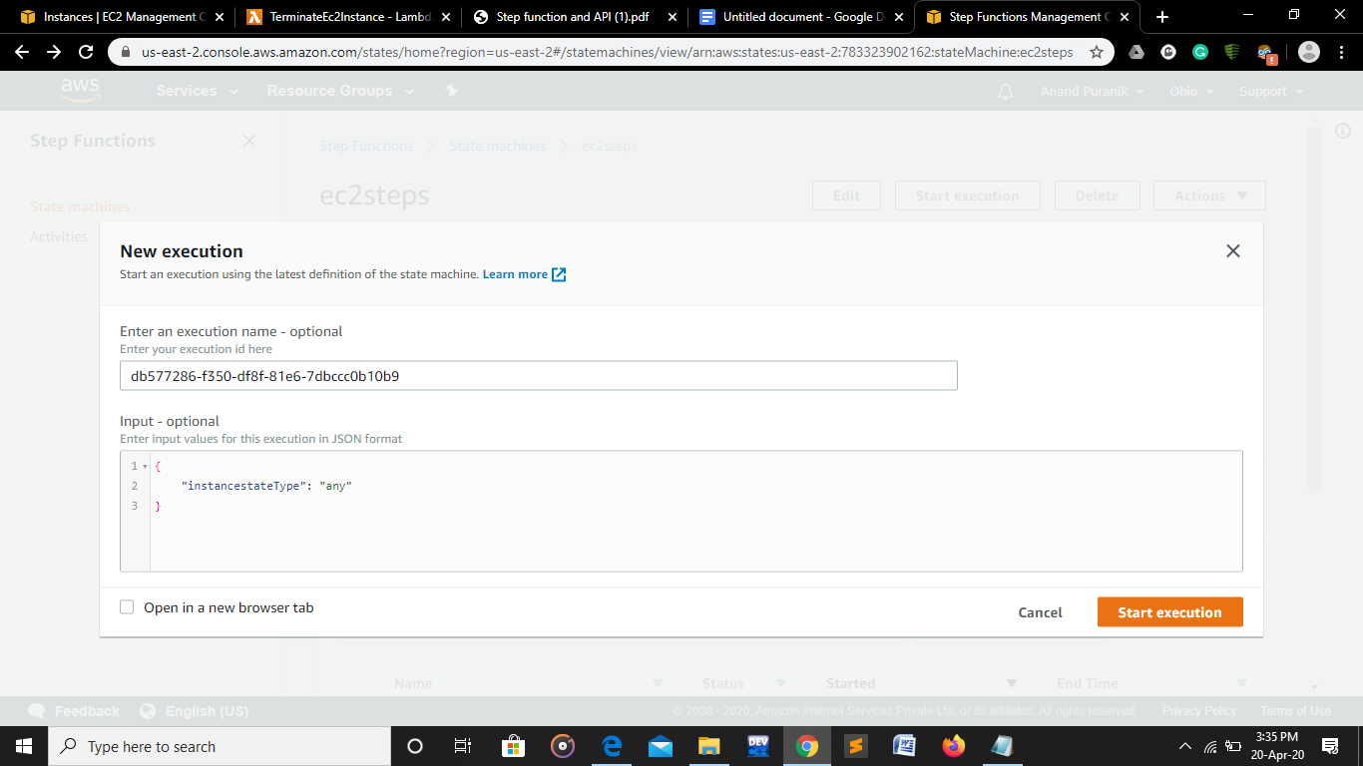

Output-

